**NOIDA INSTITUTE OF ENGINEERING AND TECHNOLOGY GREATER NOIDA**

**Approved by AICTE and Affiliated to Dr. A.P.J. Abdul Kalam**

**Technical University Uttar Pradesh, Lucknow**



**COURSE FILE**

**COURSE: B.TECH. (CSDS) SEMESTER: V**

**Department of Data Science**

**2022-23**

|  | Index | SESSION-2022-23 |
| --- | --- | --- |
| SEM-5TH (ODD) |

| **S.No** | **Content** |
| --- | --- |
| **(A)** | **Pre Defined Documents** |
| **1** | Vision & Mission of College and Department |
| **2** | Subject Summary Sheet |
| **3** | Course & Exam Scheme (W.E.F) |
| **4** | Subject Syllabus (W.E.F) |
| **5** | Course Objective |
| **6** | Course Outcomes |
| **7** | Programme Educational Objectives (PEOs) |
| **8** | Programme Outcomes (POs) |
| **9** | Programme Specific Outcomes (PSOs) |
| **10** | Mapping (Cos & POs , Cos & PEOs , Cos & PSOs) |
| **11** | Lecture Plan (Execution Plan in attendance register) |
| **12** | Academic Calendar |
| **13** | Assignments |
| **14** | Unitwise Question Bank |
| **15** | Previous Years Question Papers (last 3 year with Solution) |
| **16** | Question Paper Template |
| **(B)** | **List of Documents before one weak of Commencement of Classes** |
| **17** | Students’ List |
| **18** | Individual Time Table of the Faculty Members |
| **(C)** | **Student Performance & Monitoring (During the Classes)** |
| **19** | CT-1, CT-2 & PUT Question Papers with solutions. |
| **20** | Non - Performing Students List ( Scored < 40% Marks in any Sessional exam and Detained) |
| **21** | Actions taken for improvement of Non-performing students |
| **(D)** | **Out Comes Based Documents** |
| **22** | End Semester Examination Question Paper Review & Expected Result. |
| **23** | University Result Analysis. |
| **24** | Reason for Difference between Expected Result and University Result. |
| **25** | Corrective Steps Taken for Difference in Results. |
| **26** | Cos and Pos Attainment Sheet. |

|  | Vision & Mission of the Institute | SESSION-2022-23 |
| --- | --- | --- |
| SEM-5TH (ODD) |

**Vision of Institute:**

To be an Institute of academic excellence in digital arena with global outreach delivering socially responsible professionals to become a university and an entrepreneurial hub.

**Mission of Institute**

* To impart quality education and hone student’s skills and competencies making them future ready.
* To foster an ecosystem for research, product development, innovation, incubation and entrepreneurship.
* To instill values and ethics to produce socially responsible technocrats addressing global problems.
* To develop an environment for sharing and exchange of resources globally for lifelong learning.

|  | Vision &Mission Of Department | SESSION-2022-23 |
| --- | --- | --- |
| SEM-5TH (ODD) |

**Vision**

To be a Centre of excellence in Data Science and develop globally competent and ethical technocrats to serve the society.

**Mission**

**M1:** • To impart quality education through effective teaching-learning process and increase technical capabilities in the field of Data Science making students future-ready

**M2:** • To build research, innovation and entrepreneurial ecosystem with transformational education experiences to students using new age and niche technologies.

**M3:** • To develop professionals for ethical use of data to benefit the society

|  | Subject Summary Sheet 1 | SESSION-2022-23 |
| --- | --- | --- |
| SEM-5TH (ODD) |

| **Session** | **Semester** | **Branch** | **Issue Detail** | | | **CO Attainment** | **Return Detail** | | |
| --- | --- | --- | --- | --- | --- | --- | --- | --- | --- |
| **Date of issue** | **Subject Coordinator Name** | **Signature** | **Date of Return** | **Receiver Name** | **Signature** |
|  |  |  |  |  |  |  |  |  |  |
|  |  |  |  |  |  |  |  |  |  |
|  |  |  |  |  |  |  |  |  |  |
|  |  |  |  |  |  |  |  |  |  |
|  |  |  |  |  |  |  |  |  |  |

|  | Subject Summary Sheet 2 | SESSION-2022-23 |
| --- | --- | --- |
| SEM-5TH (ODD) |

| **Session** | **Semester** | **Branch** | **Section** | **No of Student** | **Result Brackets** | | | **Result Analysis** | **Overall Result** | **Top five Student Name** | **Faculty Signature** |
| --- | --- | --- | --- | --- | --- | --- | --- | --- | --- | --- | --- |
| **>30%** | **≤ 30% to < 60%** | **60% ≥** |
| **2020-21** |  |  |  |  |  |  |  |  |  |  |  |
|  |  |  |  |  |  |  |
|  |  |  |  |  |  |  |
| **2021-22** |  |  |  |  |  |  |  |  |  |  |  |
|  |  |  |  |  |  |  |
| **2022-23** |  |  |  |  |  |  |  |  |  |  |  |
|  |  |  |  |  |  |  |
|  |  |  |  |  |  |  |

|  | Course & Exam Scheme (W.E.F 16/06/2022) | SESSION-2022-23 |
| --- | --- | --- |
| SEM-5TH (ODD) |

|  | Subject Syllabus (W.E.F 16/06/2022) | SESSION-2022-23 |
| --- | --- | --- |
| SEM-5TH (ODD) |

| **B. TECH. SECOND YEAR** | | | |
| --- | --- | --- | --- |
| **Course Code** |  | **L T P** | **Credits** |
| **Course Title** | **MACHINE LEARNING** | **3 0 0** | **3** |
| **Course objective:** To introduction to the fundamental concepts in machine learning and popular machine learning algorithms. To understand the standard and most popular supervised learning algorithm. | | | |
| **Pre-requisites:** Basic Knowledge of Machine learning. | | | |
| **Course Contents / Syllabus** | | | |
| **UNIT-I** | **UNIT-I** | | **UNIT-I** |
| INTRODUCTION – Learning, Types of Learning, Well defined learning problems, Designing a Learning System, History of ML, Introduction of Machine Learning Approaches, Introduction to Model Building, Sensitivity Analysis, Underfitting and Overfitting, Bias and Variance, Concept Learning Task, Find – S Algorithms, Version Space and Candidate Elimination Algorithm, Inductive Bias, Issues in Machine Learning and Data Science Vs Machine Learning. | | | |
| **UNIT-II** | | | |
| Classification and Regression, Regression: Linear Regression, Multiple Linear Regression, Logistic Regression, Polynomial Regression, Decision Trees: ID3, C4.5, CART.  **Apriori Algorithm:** Market basket analysis, Association Rules.  **Neural Networks**: Introduction, Perceptron, Multilayer Perceptron, Support vector machine. | | | |
| **UNIT-III** | **UNIT-III** | | **UNIT-III** |
| Introduction to clustering, K-means clustering, K-Nearest Neighbor, Iterative distance-based clustering, Dealing with continuous, categorical values in K-Means, Hierarchical: AGNES, DIANA, Partitional: K-means clustering, K-Mode Clustering, density-based clustering, Expectation Maximization, Gaussian Mixture Models. | | | |
| **UNIT-IV** | | | |
| Bayesian Learning, Bayes Optimal Classifier, Naıve Bayes Classifier, Bayesian Belief Networks.  **Ensembles methods:** Bagging & boosting, C5.0 boosting, Random Forest, Gradient Boosting Machines and XGBoost. | | | |
| **UNIT-V** | **UNIT-V** | | **UNIT-V** |
| **Reinforcement Learning:** Introduction to Reinforcement Learning, Learning Task, Example of Reinforcement Learning in Practice, Learning Models for Reinforcement – (Markov Decision process, Q Learning – Q Learning function, QLearning Algorithm), Application of Reinforcement Learning.  **Case Study:** Health Care, E Commerce, Smart Cities. | | | |
| **Text books:** | | | |
| 1. 1) Marco Gori , Machine Learning: A Constraint-Based Approach, Morgan Kaufmann. 2017 | | | |
| 1. Ethem Alpaydin, Machine Learning: The New AI, MIT Press-2016 | | | |
| 1. Bishop, Christopher. Neural Networks for Pattern Recognition. New York, NY: Oxford University Press, 1995 | | | |
| 1. Tom M. Mitchell, “Machine Learning”, McGraw-Hill, 2010 | | | |
| **Reference Books:** | | | |
| 1. Ryszard, S., Michalski, J. G. Carbonell and Tom M. Mitchell, Machine Learning: An Artificial Intelligence Approach, Volume 1, Elsevier. 2014 | | | |
| 1. Stephen Marsland, Taylor & Francis 2009. Machine Learning: An Algorithmic Perspective. | | | |
| 1. Ethem Alpaydin, (2004) “Introduction to Machine Learning (Adaptive Computation and Machine Learning)”, The MIT Press. | | | |
| 1. Fundamentals of Machine Learning for Predictive Data Anayltics: Algorithms, Worked Examples, and Case Studies 1st Edition by [John D. Kelleher](https://www.amazon.com/John-D-Kelleher/e/B013YPGHQS/ref=dp_byline_cont_book_1) | | | |

|  | Course Objectives | SESSION-2022-23 |
| --- | --- | --- |
| SEM-5TH (ODD) |

## Course Objectives: In this course students will learn about



|  | Course Outcomes | SESSION-2022-23 |
| --- | --- | --- |
| SEM-5TH (ODD) |

**Course Outcomes: At the end of this course students will demonstrate the ability to:**

| **Course outcome:** After completion of this course students will be able to: | | |
| --- | --- | --- |
| CO1 | Understanding utilization and implementation proper machine learning algorithm. | K2 |
| CO2 | Understand the basic supervised machine learning algorithms. | K2 |
| CO3 | Understand the difference between supervise and unsupervised learning. | K2 |
| CO4 | Understand algorithmic topics of machine learning and mathematically deep enough to introduce the required theory. | K2 |
| CO5 | Apply an appreciation for what is involved in learning from data. | K3 |

|  | Program Education Objectives | SESSION-2022-23 |
| --- | --- | --- |
| SEM-5TH (ODD) |

**Program Educational Objectives**

PEO1: Solve real time complex problems and adapt to technological changes with the ability of lifelong learning.

PEO2: Work as data scientists, entrepreneurs and bureaucrats for goodwill of the society and pursue higher education.

PEO3: Exhibit professional ethics and moral values with good leadership qualities and effective interpersonal skills

|  | Program Outcomes | SESSION-2022-23 |
| --- | --- | --- |
| SEM-5TH (ODD) |

## Program Outcomes

**1. Engineering knowledge:** Apply the knowledge of mathematics, science, engineering fundamentals, and an engineering specialization for the solution of complex engineering problems.

**2. Problem analysis:** Identify, formulate, research literature, and analyse complex engineering problems reaching substantiated conclusions using first principles of mathematics, natural sciences, and engineering sciences.

**3. Design/development of solutions:** Design solutions for complex engineering problems and design system components or processes that meet the specified needs with appropriate consideration for public health and safety, and cultural, societal, and environmental considerations.

**4. Conduct investigations of complex problems:** Use research-based knowledge and research methods including design of experiments, analysis and interpretation of data, and synthesis of information to provide valid conclusions.

**5. Modern tool usage:** Create, select, and apply appropriate techniques, resources, and modern engineering and IT tools, including prediction and modeling to complex engineering activities, with an understanding of the limitations.

**6. The engineer and society:** Apply reasoning informed by the contextual knowledge to assess societal, health, safety, legal and cultural issues and the consequent responsibilities relevant to the professional engineering practice.

**7. Environment and sustainability:** Understand the impact of the professional engineering solutions in societal and environmental contexts, and demonstrate the knowledge of, and need for sustainable development.

**8. Ethics:** Apply ethical principles and commit to professional ethics and responsibilities and norms of the engineering practice.

**9. Individual and team work:** Function effectively as an individual, and as a member or leader in diverse teams, and in multidisciplinary settings.

**10. Communication:** Communicate effectively on complex engineering activities with the engineering community and with the society at large, such as, being able to comprehend and write effective reports and design documentation, make effective presentations, and give and receive clear instructions.

**11. Project management and finance:** Demonstrate knowledge and understanding of the engineering and management principles and apply these to one’s own work, as a member and leader in a team, to manage projects and in multidisciplinary environments.

**12. Life-long learning:** Recognize the need for, and have the preparation and ability to engage in independent and life-long learning in the broadest context of technological change.

|  | Program Specific Outcomes | SESSION-2022-23 |
| --- | --- | --- |
| SEM-5TH (ODD) |

| **S.NO.** | **Program Specific Outcomes** | **PSO Description** |
| --- | --- | --- |
| 1 | **PSO1** | Analyze, design, and develop solutions by applying fundamental concepts of Machine Learning. |
| 2 | **PSO2** | Apply technical knowledge while using modern tools and technologies for solving complex problems. |
| 3 | **PSO3** | Collaborate different fields of science and technology with right attitude, to work as an individual or as a team, demonstrating professional ethics for the well-being of society |

|  | Mapping (Cos & POs , Cos & PEOs , Cos & PSOs) | SESSION-2022-23 |
| --- | --- | --- |
| SEM-5TH (ODD) |

**Mapping of Course Outcomes and Program Outcomes, Course Outcomes and Program Specific Outcomes** :

|  | **PO1** | **PO2** | **PO3** | **PO4** | **PO5** | **PO6** | **PO7** | **PO8** | **PO9** | **PO10** | **PO11** | **PO12** |
| --- | --- | --- | --- | --- | --- | --- | --- | --- | --- | --- | --- | --- |
| **CO1** | 2 | 1 | 1 | 1 | 1 | 0 | 0 | 0 | 1 | 0 | 1 | 2 |
| **CO2** | 3 | 2 | 2 | 2 | 2 | 0 | 0 | 1 | 1 | 0 | 1 | 2 |
| **CO3** | 2 | 2 | 2 | 2 | 2 | 1 | 2 | 0 | 1 | 0 | 1 | 2 |
| **CO4** | 2 | 3 | 2 | 3 | 3 | 1 | 0 | 0 | 1 | 0 | 1 | 2 |
| **CO5** | 2 | 3 | 2 | 3 | 3 | 0 | 0 | 0 | 0 | 2 | 1 | 2 |
| **AVERAGE** | 2.2 | 2.2 | 1.8 | 2.2 | 2.2 | 0.4 | 0.4 | 0.2 | 0.8 | 0.4 | 1 | 2 |

**Mapping of Course Outcomes and Educational Objectives** **Program** :

| **CO** | **PSO1** | **PSO2** |
| --- | --- | --- |
|  |  |  |
|  |  |  |
|  |  |  |
|  |  |  |
|  |  |  |
|  |  |  |

|  | **Lecture Plan of Unit -I** | SESSION-2022-23 |
| --- | --- | --- |
| SEM-5TH (ODD) |

**Total Period: 8**

| **Sr. No.** | **No. of Periods** | **Topics/Sub Topics** | **Text Books** | **CO Covered** |
| --- | --- | --- | --- | --- |
| 1. | 1 | INTRODUCTION – Learning, Types of Learning, Well defined learning problems, |  | CO1 |
| 2. | 1 | Designing a Learning System, History of ML |  | CO1 |
| 3. | 1 | Introduction of Machine Learning Approaches |  | CO2 |
| 4. | 1 | Introduction to Model Building, Sensitivity Analysis |  | CO1 |
| 5. | 1 | Underfitting and Overfitting |  | CO1 |
| 6. | 1 | Bias and Variance, Concept Learning Task, |  | CO1 |
| 7. | 1 | Find – S Algorithms, Version Space and Candidate Elimination Algorithm, Inductive Bias, |  | CO1 |
| 8. | 1 | Issues in Machine Learning and Data Science Vs Machine Learning. |  | CO1 |

**Signature of Faculty**

|  | **Lecture Plan of Unit -II** | SESSION-2022-23 |
| --- | --- | --- |
| SEM-5TH (ODD) |

**Total Period: 8**

| **Sr. No.** | **No. of Periods** | **Topics/Sub Topics** | **Text -Books** | **CO Covered** |
| --- | --- | --- | --- | --- |
| 1. | 1 | Classification and Regression, Regression: Linear Regression |  | CO2 |
| 2. | 1 | Multiple Linear Regression |  | CO2 |
| 3. | 1 | Logistic Regression, Polynomial Regression |  | CO2 |
| 4. | 1 | Decision Trees: ID3, C4.5, |  | CO2 |
| 5. | 1 | CART, **Apriori Algorithm:** Market basket analysis |  | CO2 |
| 6. | 1 | **Apriori Algorithm:** Association Rules. |  | CO2 |
| 7. | 1 | **Neural Networks**: Introduction, Perceptron, |  | CO2 |
| 8. | 1 | Multilayer Perceptron, Support vector machine |  | CO2 |

**Name & Sign.Of Faculty**

|  | **Lecture Plan of Unit -III** | SESSION-2022-23 |
| --- | --- | --- |
| SEM-5TH (ODD) |

**Total Period: 8**

| **Sr. No.** | **No. of Periods** | **Topics/Sub Topics** | **Text Books** | **CO Covered** |
| --- | --- | --- | --- | --- |
| 1. | 1 | Introduction to clustering, K-means clustering, |  | CO3 |
| 2. | 1 | K-Nearest Neighbor, |  | CO3 |
| 3. | 1 | Iterative distance-based clustering, |  | CO3 |
| 4. | 1 | Dealing with continuous, |  | CO3 |
| 5. | 1 | categorical values in K-Means, |  | CO3 |
| 6 | 1 | Hierarchical: AGNES, DIANA, Partitional: K-means clustering,, |  | CO3 |
| 7 | 1 | K-Mode Clustering, density-based clustering, |  | CO3 |
| 8 | 1 | Expectation Maximization, Gaussian Mixture Models. |  | CO3 |

**Name & Sign. Of Faculty**

|  | **Lecture Plan of Unit -IV** | SESSION-2022-23 |
| --- | --- | --- |
| SEM-5TH (ODD) |

**Total Period: 8**

| **Sr. No.** | **No. of Periods** | **Topics/Sub Topics** | **Text Books** | **CO Covered** |
| --- | --- | --- | --- | --- |
| 1. | 1 | Bayesian Learning, |  | CO4 |
| 2. | 1 | Bayes Optimal Classifier |  | CO4 |
| 3. | 1 | Naive Bayes Classifier, |  | CO4 |
| 4. | 1 | Bayesian Belief Networks. |  | CO4 |
| 5. | 1 | **Ensembles methods:** Bagging & boosting, |  | CO4 |
| 6. | 1 | C5.0 boosting, |  | CO4 |
| 7. | 1 | Random Forest, Gradient Boosting. |  | CO4 |
| 8. | 1 | Machines and XGBoost |  | CO4 |

**Name & Sign.Of Faculty**

|  | **Lecture Plan of Unit –V** | SESSION-2022-23 |
| --- | --- | --- |
| SEM-5TH (ODD) |

**Total Period: 8**

| **Sr. No.** | **No. of Periods** | **Topics/Sub Topics** | **Text Books** | **CO Covered** |
| --- | --- | --- | --- | --- |
| 1. | 1 | **Reinforcement Learning:** Introduction to Reinforcement Learning, |  | CO5 |
| 2 | 1 | Learning Task, Example of Reinforcement Learning in Practice |  | CO5 |
| 3 | 1 | Learning Models for Reinforcement |  | CO5 |
| 4 | 1 | Markov Decision process, Q Learning – |  | CO5 |
| 5 | 1 | Q Learning function, QLearning Algorithm |  | CO5 |
| 6 | 1 | Application of Reinforcement Learning. |  | CO5 |
| 7 | 1 | **Case Study:** Health Care |  | CO5 |
| 8 | 1 | **Case Study:** E Commerce, Smart Cities. |  | CO5 |

**Name & Sign.Of Faculty**

|  | **Academic Calendar** | SESSION-2022-23 |
| --- | --- | --- |
| SEM-5TH (ODD) |

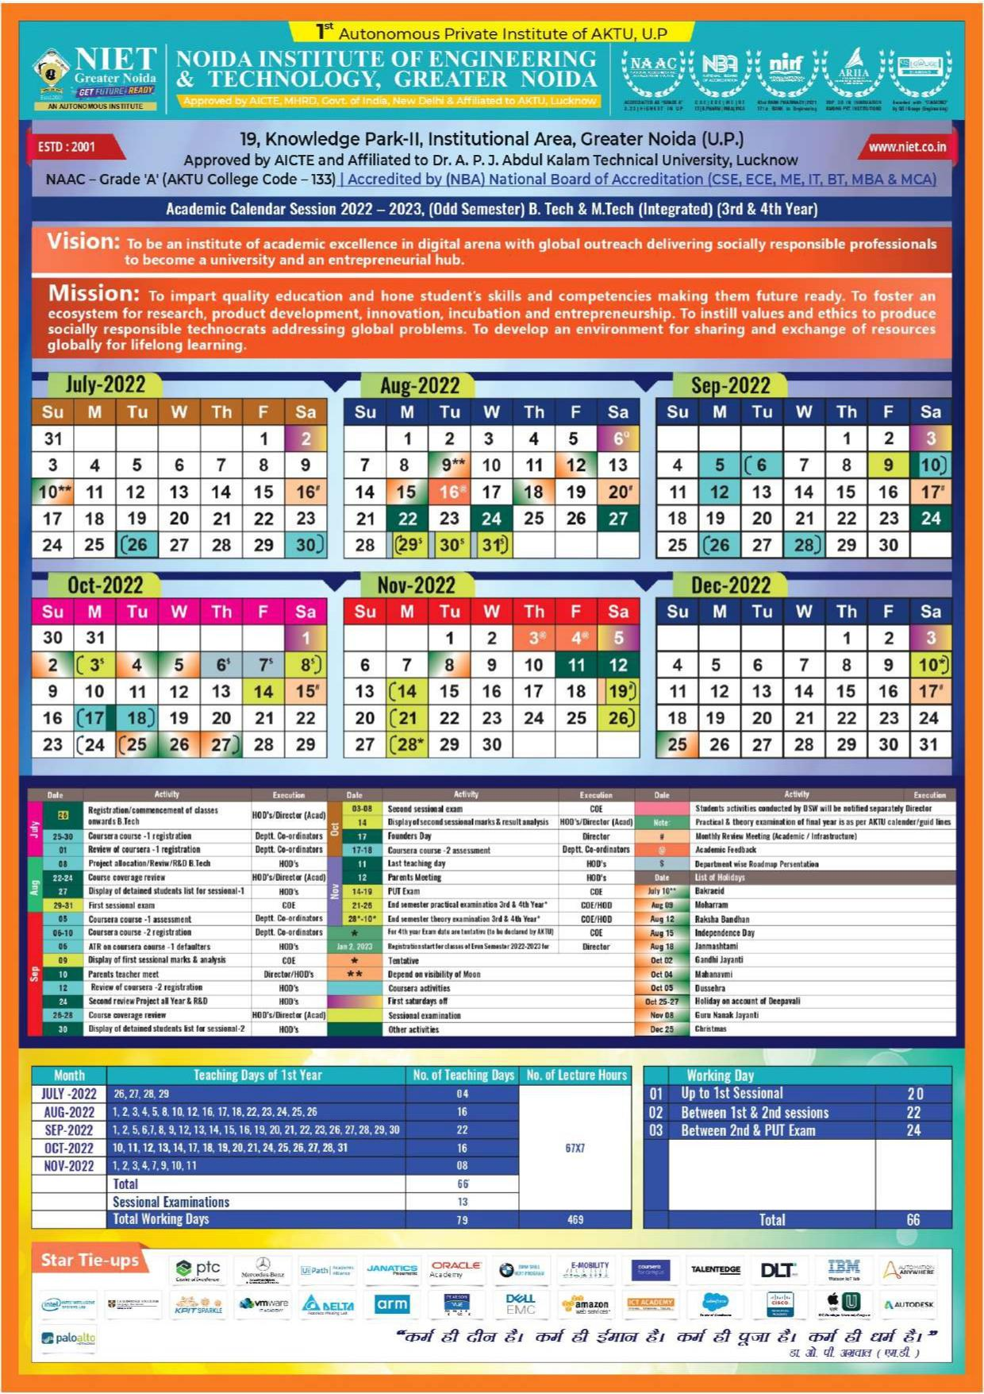

|  |  |  |
| --- | --- | --- |
|  |
|  |  |  |

|  | ASSIGNMENT 1 | SESSION-2022-23 |
| --- | --- | --- |
| SEM-5TH (ODD) |

### Subject Name: Machine Learning Subject Code ACSML0401 Name of Course Coordinator: Sofia K. Pillai/Aradhana Saini Class: DS V SEM A/B/C

### Submission Date: 29/08/2022

1. Define Machine Learning. Discuss with example some useful application of Machine Learning. [CO1]

### 2. Differentiate between Supervised, Unsupervised and Reinforcement Learning. [CO1]

3. What do you mean by a well-posed learning problem [CO1]

### 4. Describe in detail all the steps involved in designing a learning system. [CO1]

5. What do you mean by general-to-specific ordering of hypothesis? [CO1]

### 6. Explain the following: [CO1]

### (a) Concept Learning

### (b) Consistent Hypothesis

### (c)Version Space

### (d)General Boundary

### (e)Specific Hypothesis

7. Describe Find S algorithm. What are the properties and complaints of Find – S? [CO1]

8. Perform Find S algorithm on the given dataset: [CO1]

### 9. What are the issues in Machine Learning? [CO1]

### 10. Write the difference between Supervised and Unsupervised Learning. [CO1]

# 

# 

.

|  | ASSIGNMENTS 3 | SESSION-2022-23 |
| --- | --- | --- |
| SEM-5TH (ODD) |

**Subject:**

|  | ASSIGNMENT 4 | SESSION-2022-23 |
| --- | --- | --- |
| SEM-5TH (ODD) |

**Subject:**

|  | ASSIGNMENT 5 | SESSION-2022-23 |
| --- | --- | --- |
| SEM-5TH (ODD) |

**Subject:**

|  | Question Bank (Unit 1) | SESSION-2022-23 |
| --- | --- | --- |
| SEM-5TH (ODD) |

**Subject:**

|  | Question Bank (Unit 2) | SESSION-2022-23 |
| --- | --- | --- |
| SEM-5TH (ODD) |

**Subject:**

1. .

|  | Question Bank (Unit 3) | SESSION-2022-23 |
| --- | --- | --- |
| SEM-5TH (ODD) |

**Subject:**

|  | Question Bank (Unit 4) | SESSION-2022-23 |
| --- | --- | --- |
| SEM-5TH (ODD) |

**Subject:**

|  | Question Bank (Unit 5) | SESSION-2022-23 |
| --- | --- | --- |
| SEM-5TH (ODD) |

**Subject:**

|  | Previous Years Question Paper 1 | SESSION-2022-23 |
| --- | --- | --- |
| SEM-5TH (ODD) |

|  | Previous Years Question Paper 1 | SESSION-2022-23 |
| --- | --- | --- |
| SEM-5TH (ODD) |

|  | Previous Years Question Paper 2 | SESSION-2022-23 |
| --- | --- | --- |
| SEM-5TH (ODD) |

|  | Previous Years Question Paper 3 | SESSION-2022-23 |
| --- | --- | --- |
| SEM-5TH (ODD) |

|  | Question Papers Template | SESSION-2022-23 |
| --- | --- | --- |
| SEM-5TH (ODD) |

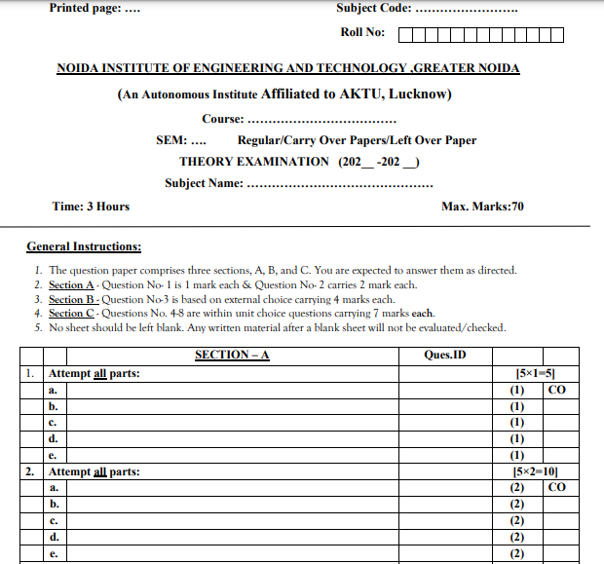

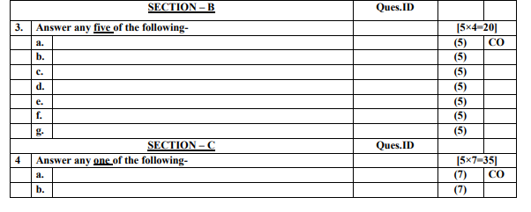

|  | Question Papers Template | SESSION-2022-23 |
| --- | --- | --- |
| SEM-5TH (ODD) |

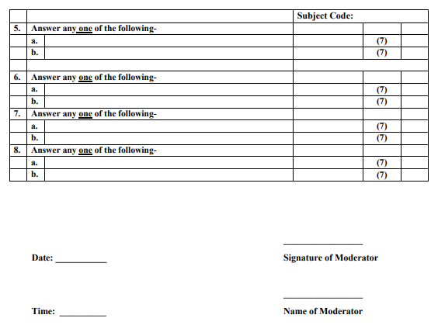

|  | Student List | SESSION-2022-23 |
| --- | --- | --- |
| SEM-5TH (ODD) |

| **Roll.No** | **Student Name** |
| --- | --- |
|  |  |
|  |  |
|  |  |
|  |  |
|  |  |
|  |  |
|  |  |
|  |  |
|  |  |
|  |  |
|  |  |
|  |  |
|  |  |
|  |  |
|  |  |
|  |  |
|  |  |
|  |  |
|  |  |
|  |  |
|  |  |
|  |  |
|  |  |
|  |  |
|  |  |
|  |  |
|  |  |
|  |  |
|  |  |
|  |  |
|  |  |
|  |  |
|  |  |
|  |  |
|  |  |

|  | Individual Time Table of the Faculty Members | SESSION-2022-23 |
| --- | --- | --- |
| SEM-5TH (ODD) |

**Faculty Name : X**

| **SECTION VII TIME TABLE (2020-21) ODD Sem ONLINE** | | | | | |
| --- | --- | --- | --- | --- | --- |
| **Day/ Time** | **10 am to 11** | **12:00 Pm to 1:00** | **12:45 to 01:30** | **03:00PM to 04:00** | **03:30 to 04:15** |
| **Monday** |  |  |  |  |  |
| **Tuesday** |  |  |  |  |  |
| **Wednesday** |  |  |  |  |  |
| **Thursday** |  |  |  |  |  |
| **Friday** |  |  |  |  |  |
|  |  |  |  |  |  |

**Faculty Name : Y**

| **SECTION VII TIME TABLE (2020-21) ODD Sem ONLINE** | | | | | |
| --- | --- | --- | --- | --- | --- |
| **Day/ Time** | **10 am to 11** | **12:00 Pm to 1:00** | **12:45 to 01:30** | **03:00PM to 04:00** | **03:30 to 04:15** |
| **Monday** |  |  |  |  |  |
| **Tuesday** |  |  |  |  |  |
| **Wednesday** |  |  |  |  |  |
| **Thursday** |  |  |  |  |  |
| **Friday** |  |  |  |  |  |
|  |  |  |  |  |  |

|  | CT-1 Question Papers with solutions | SESSION-2022-23 |
| --- | --- | --- |
| SEM-5TH (ODD) |

|  | CT-2 Question Papers with solutions | SESSION-2022-23 |
| --- | --- | --- |
| SEM-5TH (ODD) |

|  | PUT Question Papers with solutions | SESSION-2022-23 |
| --- | --- | --- |
| SEM-5TH (ODD) |

|  | Non - Performing Students List | SESSION-2022-23 |
| --- | --- | --- |
| SEM-5TH (ODD) |

| **Roll.No** | **Name** | **Total Marks** |
| --- | --- | --- |
|  |  |  |
|  |  |  |
|  |  |  |
|  |  |  |
|  |  |  |
|  |  |  |

|  | Actions taken for the improvement of Non-performing students | SESSION-2022-23 |
| --- | --- | --- |
| SEM-5TH (ODD) |

**Sample**

1. Students who have scored ≤40% marks in first sessional test shall be identified as Academically Weak Students (AWS).
2. Improvement test shall be conducted for AWS after first sessional test.
3. HOD shall arrange to conduct extra classes for AWS beyond institute hours preferably between 5:15 PM to 6:15 PM.
4. All AWS students must attend all lecture classes and maintain preferably 100% attendance.
5. AWS be allowed to appear in second sessional test and their pass percentage in second sessional test will be monitored.
6. After the analysis of second test result, the result of AWS students who appeared in the second test will be again monitored and the progress of AWS students be sent to the Director.

|  | End Semester Examination Question Paper Review & Expected Result | SESSION-2022-23 |
| --- | --- | --- |
| SEM-5TH (ODD) |

| **Session** | **Subject Code** | **Question Paper Level** | **Expected Result** | **Subject Coordinator Signature** |
| --- | --- | --- | --- | --- |
|  |  |  |  |  |
|  |  |  |  |  |

**Keywords:**

* Easy
* Easy to Moderate
* Moderate to Difficult
* Difficult

|  | University Result Analysis | SESSION-2022-23 |
| --- | --- | --- |
| SEM-5TH (ODD) |

| **Session** | **Semester** | **Branch** | **Section** | **No of Student** | **Alloted Faculty Name** | **Result Analysis** | **Faculty Signature** | **HOD**  **Signature** |
| --- | --- | --- | --- | --- | --- | --- | --- | --- |
|  |  |  |  |  |  |  |  |  |
|  |  |  |  |  |  |
|  |  |  |  |  |  |
|  |  |  |  |  |  |  |  |  |
|  |  |  |  |  |  |
|  |  |  |  |  |  |  |  |  |
|  |  |  |  |  |  |
|  |  |  |  |  |  |

|  | Reason for Difference between Expected Result and University Result | SESSION-2022-23 |
| --- | --- | --- |
| SEM-5TH (ODD) |

|  | Corrective Steps Taken for Difference in Results | SESSION-2022-23 |
| --- | --- | --- |
| SEM-5TH (ODD) |

|  | Cos and Pos Attainment Sheet | SESSION-2022-23 |
| --- | --- | --- |
| SEM-5TH (ODD) |

| **Session** | **Subject code** | **Subject Name** | **Attainment** | **Subject Coordinator Signature** | **HOD**  **Signature** |
| --- | --- | --- | --- | --- | --- |
| 2021-22 | KOE-074 | XYZ | 2.85 |  |  |
| 2022-23 | KOE-074 | XYZ | 2.9 |  |  |
|  |  |  |  |  |  |
|  |  |  |  |  |  |
|  |  |  |  |  |  |